**Terna Engineering College**

**Computer Engineering Department**

**Program: Sem V**

**Course: Web Technology Laboratory (CSL504)**

**Faculty: Nayana Vaity**

LAB Manual

**PART A**

(PART A: TO BE REFFERED BY STUDENTS)

**Experiment No.02**

**A.1 Aim:**

A. Design Static web pages using Frameset and targets.

         B. Design Website using CSS.

**A.2 Prerequisite:**

1. Knowledge of World Wide Web (WWW)

2. Knowledge of core concepts of web technology.

**A.3 Outcome:**

**After successful completion of this experiment students will be able to**

1. Design static web page using HTML5
2. Understand concepts of frameset.

**A.4 Theory:**

* **HTML Frameset:**
  + - * <Frameset >: is a file that specifies how the screen is divided in to frames.
      * <Frameset ></Frameset >: tag divides the screen in to different frames either horizontally or vertically.
      * <Frameset> Attributes:

**1) rows/cols:**specify whether to divide window horizontally or vertically.

**2) Frameborder :**specify border around frame and has value Yes/No

**3) Border:** specify width of border around frame

**Frameset Example**

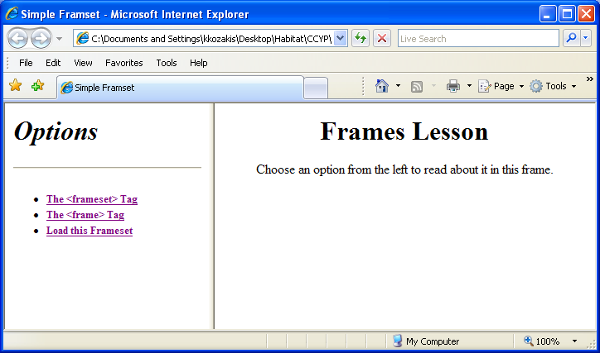

This frameset was created by the following

code: <frameset cols="35%,65%"></frameset>

**Example of Frameset:**

**Output:**

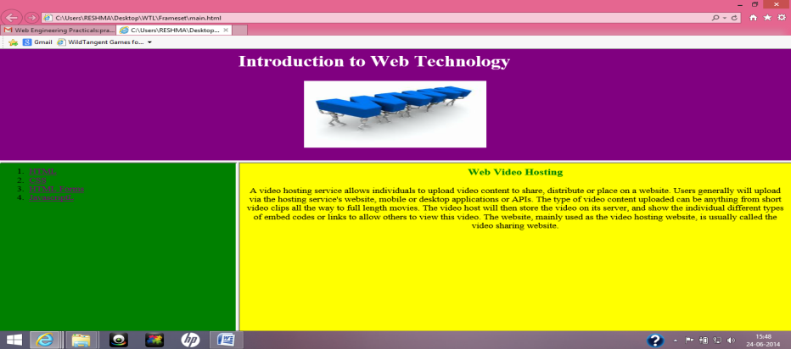

**Source Code:**

1. **Main.html**

<html>

<frameset rows="40%,60%">

<frame  src="top.html" name="frame1">

<frameset cols="30%,70%">

<frame  src="left.html" name="frame2">

<frame src="right.html" name="frame3">

</frameset>

</frameset>

</html>

1. **Left.html**

<html>

<body bgcolor="green"  text="black">

<ol>

<li><a href="HTMLIntro.html"   target="_self">HTML</a></li>

<li><a href="css.html"> CSS</a></li>

<li><a href="forms.html">HTML Forms</a></li>

<li><a href="javascript.html"  target="frame3">JavascriptL</a></li>

</body>

</html>

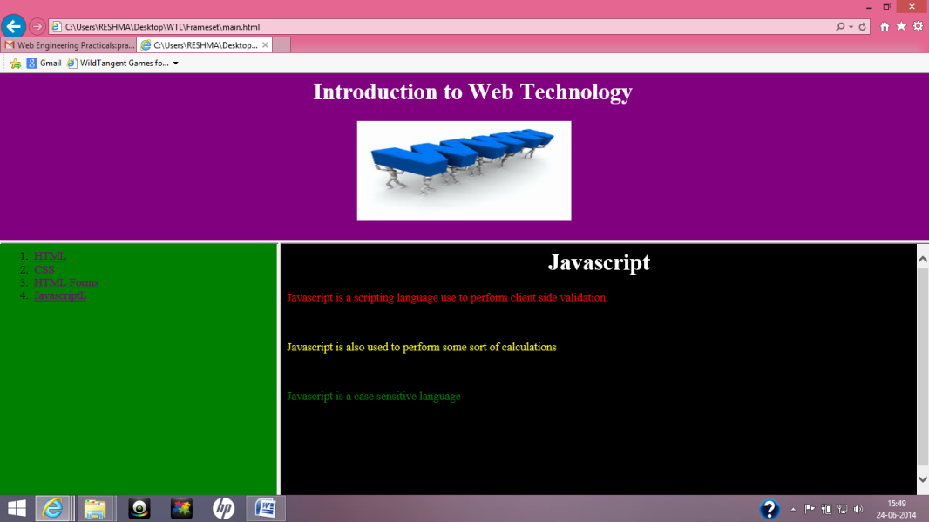

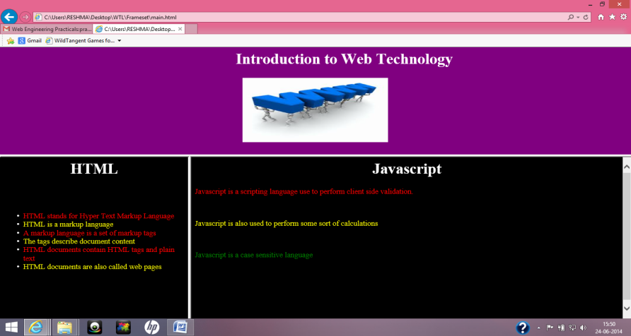

* **CSS:**

CSS is an acronym for **C**ascading **S**tyle **S**heets

CSS is a style language that defines layout of HTML documents. For example, CSS covers fonts, colours, margins, lines, height, width, background images, advanced positions and many other things.

HTML can be used to add layout to websites. But CSS offers more options and is more accurate and sophisticated. CSS is supported by all browsers today.

* + **The benefits of CSS include:**
* control layout of many documents from one single style sheet;
* more precise control of layout;
* apply different layout to different media-types (screen, print, etc.);
* numerous advanced and sophisticated techniques.
* **The basic CSS syntax**

Using **HTML** we could have done it like this:

<body bgcolor="#FF0000">

With **CSS** the same result can be achieved like this:

**body  {background-color: #FF0000;}**

**The fundamental CSS model:**

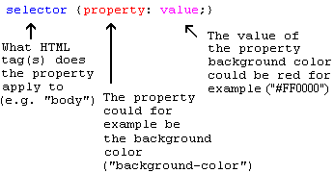

* **Applying CSS to an HTML document**

There are three ways you can apply CSS to an HTML document

**Method 1: In-line (the attribute style):** by using the HTML attribute style.

Example: <html>

<head>

<title>Example</title>

</head>

**<body style="background-color: #FF0000;">**

<p>This is a red page</p>

</body>

</html>

**Method 2: Internal (the tag style)**

Another way is to include the CSS codes using the HTML tag <style>. For example like this:

<html>

<head>

<title>Example</title>

**<style type="text/css">**

**body {background-color: #FF0000;}**

**P{ALIGH:LEFT;}**

**</style>**

</head>

<body>

<p>This is a red page</p>

</body>

</html>

**Method 3: External (link to a style sheet)**

The recommended method is to link to a so-called external style sheet.

An external style sheet is simply a text file with the extension **.css**. Like any other file, you can place the style sheet on your web server or hard disk.

The trick is to create a link from the HTML document (default.htm) to the style sheet (style.css). Such link can be created with one line of HTML code:

<link rel="stylesheet" type="text/css" **href="style/style.css"** />

The line of code must be inserted in the header section of the HTML code i.e. between the <head> and </head> tags. Like this:

<html>

<head>

<title>My document</title>

**<link rel="stylesheet" type="text/css" href="style/style.css" />**

</head>

<body>

This link tells the browser that it should use the layout from the CSS file when displaying the HTML file.

**Example: Web page using CSS**

**Output**

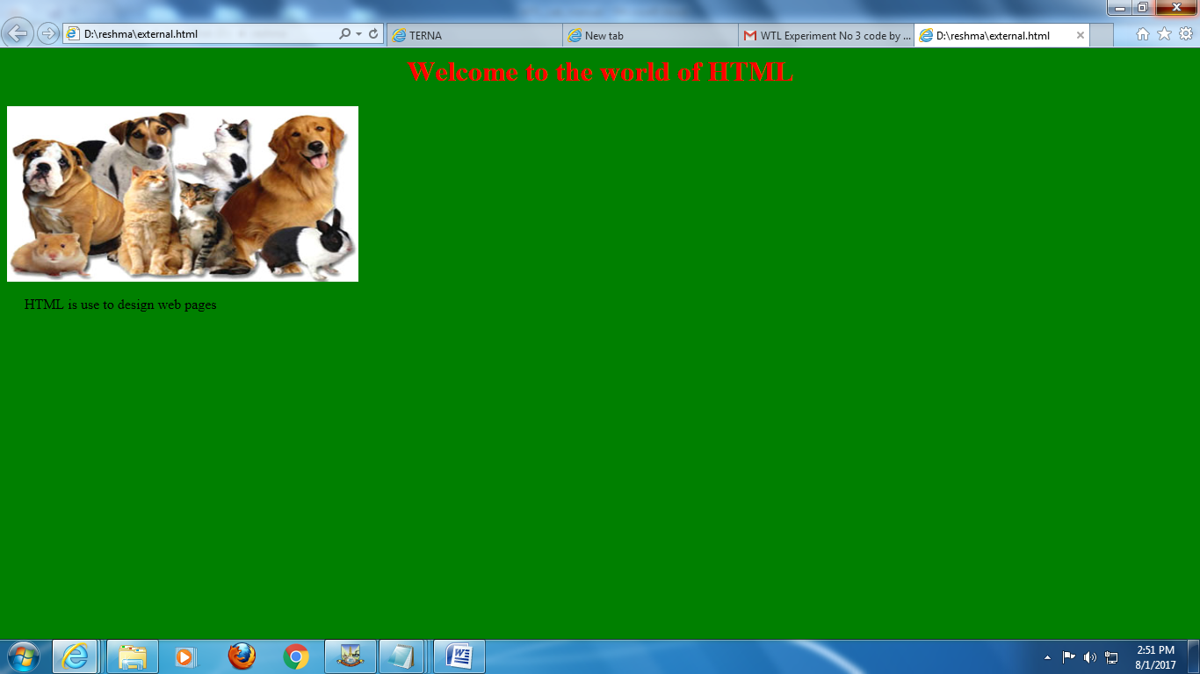

**Source Code:**

**Inlinecss.html**

<html>

<body  style="background-color:green;color:white">

……<IMG STYLE=””>…………………………………………………….

………………………………………………………….

</body>

</html>

**Internalcss.html**

<html>

<head>

<style type="text/css">

body

{

background-color:green;

color:white

}

h1

{

………….

}

img

{

……………….

}

p.C1

{

………………….

}

</style>

</head>

<body>

<h1>Welcome to the world of HTML</h1>

<imgsrc="pic1.jpg">

<p> HTML is use to design web pages</p>

</body>

</html>

**Externalcss.html**

<html>

<head>

<link   type="text/css"    rel="stylesheet"  href="style1.css"/>

</head>

<body>

<h1>Welcome to the world of HTML</h1>

<imgsrc="pic1.jpg">

<p> HTML is use to design web pages</p>

</body>

</html>

**Style1.css**

body

{

background-color:green;

text:white

}

h1

{

……………………

}

img

{

………………………….

}

p

{

……………………………

}

**PART B**

(PART B : TO BE COMPLETED BY STUDENTS)

|  |  |
| --- | --- |
| **Roll No. 75** | **Name: Sudhanshu Jena** |
| **Class : COMPS** | **Batch : TE-C** |
| **Date of Experiment: 28/07/2020** | **Date of Submission** |
| **Grade :** |  |

|  |  |
| --- | --- |
| **B.1** | **Web page Snapshot:**  **FRAMES:-** |
|  | **EXTERNAL CSS:-**    **INTERNAL CSS:-**  **INLINE CSE:-** |
|  |  |
|  |  |
| **B.2.** | **Web page source code:**  **FRAMES:-**  <html>      <frameset rows="50%,50%">      <frame  src="frame_2.html" name="frame_2">      <frameset cols="50%,50%">      <frame  src="frame_1.html" name="frame_1">      <frame src="frame_3.html" name="frame_3">      </frameset>      </frameset>  </html>  **FRAME1:-**  <!DOCTYPE html>  <html>  <head>  <style>  body {background-color: #2874A6;}  p{    text-align : justify;  }  p.image,h1{    text-align : center;  }  </style>  </head>  <body>  <h1>Mahendra Singh Dhoni</h1>  <p class="image"><img src="ms.jpg"></p>  <p>Mahendra Singh Dhoni (born 7 July 1981), commonly known as MS Dhoni, is an Indian international cricketer who captained the Indian national team in limited-overs formats from 2007 to 2016 and in Test cricket from 2008 to 2014. Under his captaincy, India won the 2007 ICC World Twenty20, the 2010 and 2016 Asia Cups, the 2011 ICC Cricket World Cup and the 2013 ICC Champions Trophy. A right-handed middle-order batsman and wicket-keeper, Dhoni is one of the highest run scorers in One Day Internationals (ODIs) with more than 10,000 runs scored and is considered an effective "finisher" in limited-overs formats. He is also regarded by some as one of the best wicket-keepers in modern limited-overs international cricket.</p>  </body>  </html>  **FRAME2:-**  <!DOCTYPE html>  <html>  <head>  <style>  body {background-color: #1B4F72;}  p{    text-align : justify;  }  p.image,h1{    text-align : center;  }  </style>  </head>  <body>  <h1>Sachin Ramesh Tendulkar</h1>  <p class="image"><img src="st.jpg"></p>  <p>Sachin Ramesh Tendulkar ( born 24 April 1973) is a former Indian international cricketer and a former captain of the Indian national team. He is widely regarded as one of the greatest batsman in the history of cricket. He is the highest run scorer of all time in International cricket. Tendulkar took up cricket at the age of eleven, made his Test debut on 15 November 1989 against Pakistan in Karachi at the age of sixteen, and went on to represent Mumbai domestically and India internationally for close to twenty-four years. He is the only player to have scored one hundred international centuries, the first batsman to score a double century in an ODI, the holder of the record for the most number of runs in both Test and ODI, and the only player to complete more than 30,000 runs in international cricket. He is colloquially known as Little Master or Master Blaster, In 2001, Sachin Tendulkar became the first batsman to complete 10,000 ODI runs in his 259 innings. In 2002, halfway through his career, Wisden Cricketers' Almanack ranked him the second greatest Test batsman of all time, behind Don Bradman, and the second greatest ODI batsman of all time, behind Viv Richards. Later in his career, Tendulkar was a part of the Indian team that won the 2011 World Cup, his first win in six World Cup appearances for India. He had previously been named "Player of the Tournament" at the 2003 edition of the tournament, held in South Africa. In 2013, he was the only Indian cricketer included in an all-time Test World XI named to mark the 150th anniversary of Wisden Cricketers' Almanack.</p>  </body>  </html></html>  **FRAME3:-**  <!DOCTYPE html>  <html>  <head>  <style>  body {background-color: #3498DB;}  p{    text-align : justify;  }  p.image,h1{    text-align : center;  }  </style>  </head>  <body>  <h1>Rohit Gurunath Sharma</h1>  <p class="image"><img src="rs.jpg"></p>  <p>Rohit Gurunath Sharma (born 30 April 1987) is an Indian international cricketer who is the vice-captain of the India national team in limited-overs formats. He is a right-handed batsman and was an occasional right-arm off break bowler. He plays for Mumbai in domestic cricket and captains Mumbai Indians in the Indian Premier League. Rohit Sharma has won the IPL, title as a skipper four times for Mumbai Indians. He is currently the only player in the cricket history to score three double hundreds in ODIs, the highest being 264 runs. He is the only batsman in the world to hit five centuries in a single World Cup. He is currently ranked as 2nd in the list of ODI batsmen.</p>  </body>  </html>  **EXTERNAL CSS:-**  <!DOCTYPE html>  <html>  <head>  <link rel="stylesheet" type="text/css" href="style.css">  </head>  <body>  <h1>Central Bureau of Investigation</h1>  <p class="image"><img src="cbi.jpg"></p>  <p>The Central Bureau of Investigation (CBI) is the premier investigating agency of India.      Operating under the jurisdiction of the Ministry of Personnel, Public Grievances and Pensions,      the CBI is headed by the Director. Originally set up to investigate bribery and governmental corruption,       in 1965 it received expanded jurisdiction to investigate breaches of central laws enforceable by the Government of India,        multi-state organised crime, multi-agency or international cases.        The agency has been known to investigate several economic crimes,        special crimes, cases of corruption and other high-profile cases.        CBI is exempted from the provisions of the Right to Information Act.      CBI is India's officially designated single point of contact for liaison with the Interpol.</p>  </body>  </html>  **INTERNAL CSS:-**  <!DOCTYPE html>  <html>  <head>  <style>  body {background-color: #34495E;}  p{    text-align : justify;  }  p.image,h1{    text-align : center;  }  </style>  </head>  <body>  <h1> ENGINEERING </h1>  <p class="image"><img src="Engineering.jpg"></p>  <p>Engineering is the application of science and math to solve problems.     Engineers figure out how things work and find practical uses for scientific discoveries.     Scientists and inventors often get the credit for innovations    that advance the human condition, but it is engineers who are instrumental in making those innovations available to the world.<br/>    Engineers design, evaluate, develop, test, modify, install, inspect and maintain a wide variety of products and systems.    They also recommend and specify materials and processes, supervise manufacturing and construction, conduct failure analysis,    provide consulting services and teach engineering courses in colleges and universities.  </p>  </body>  </html>  **INLINE CSS:-**  <!DOCTYPE html>  <html>  <head>    </head>  <body style="background-color: #154360">  <h1 style="text-align : center"><img src="isro.jpg" width="200" height="200"><br/>Indian Space Research Organisation</h1>  <p style="text-align : justify" >The Indian Space Research Organisation (ISRO, /ˈɪsroʊ/) is the space agency of the Government of India headquartered in the city of Bengaluru. Its vision is to "harness space technology for national development while pursuing space science research and planetary exploration."[6] The Indian National Committee for Space Research (INCOSPAR) was established in the tenure of Jawaharlal Nehru  under the DAE in 1962, with the urging of scientist Vikram Sarabhai recognizing the need in space research. INCOSPAR grew and became ISRO in 1969, also under the Department of Atomic Energy (DAE).[13][14] In 1972 Government of India setup a Space Commission and the Department of Space (DOS),bringing ISRO under the DOS. The establishment of ISRO thus institutionalized space research activities in India.It is managed by the Department of Space, which reports to the Prime Minister of India.</p>  </body>  </html>  **STYLE CSS:-**  body{      background-color : #17202A;   }   p{       text-align : justify;       color: #3498DB;     }   h1{       text-align : center;       color: #F0F3F4;   }   p.image{       text-align : center;   } |
|  |  |
|  |  |
| **B.3** | **Question of Curiosity:**   1. What do you mean by **Targets**? What are advantages ofcreating  targets?   **ANS:-** Anchor links may have a **target** attribute which controls what happens when that link is clicked. One of the possible values of that attribute is _blank , which tells the browser to open a new window (or tab, if that's the user's preference) when that link is clicked.  The target attribute specifies a name or a keyword that indicates where to display the response that is received after submitting the form.  The target attribute defines a name of, or keyword for, a browsing context (e.g. tab, window, or inline frame).   1. What are various types of targets?   **ANS:-**   |  |  | | --- | --- | | **Value** | **Description** | | _blank | Opens the link in a new window or tab | | _self | Default. Opens the link in the same frame as it was clicked | | _parent | Opens the link in the parent frame | | _top | Opens the link in the full body of the window | | *framename* | Opens the link in a named frame | |
|  |  |
| **B.4** | **Conclusion:**  After successful completion of this experiment students will be able to design static web page using HTML5 and understand concepts of frameset. |